Project 2: Active Directory Setup in Azure (End-to-End)
Author: Hari Manchikanti
Purpose: Managing AD-DS through RDP

Resource Group Created
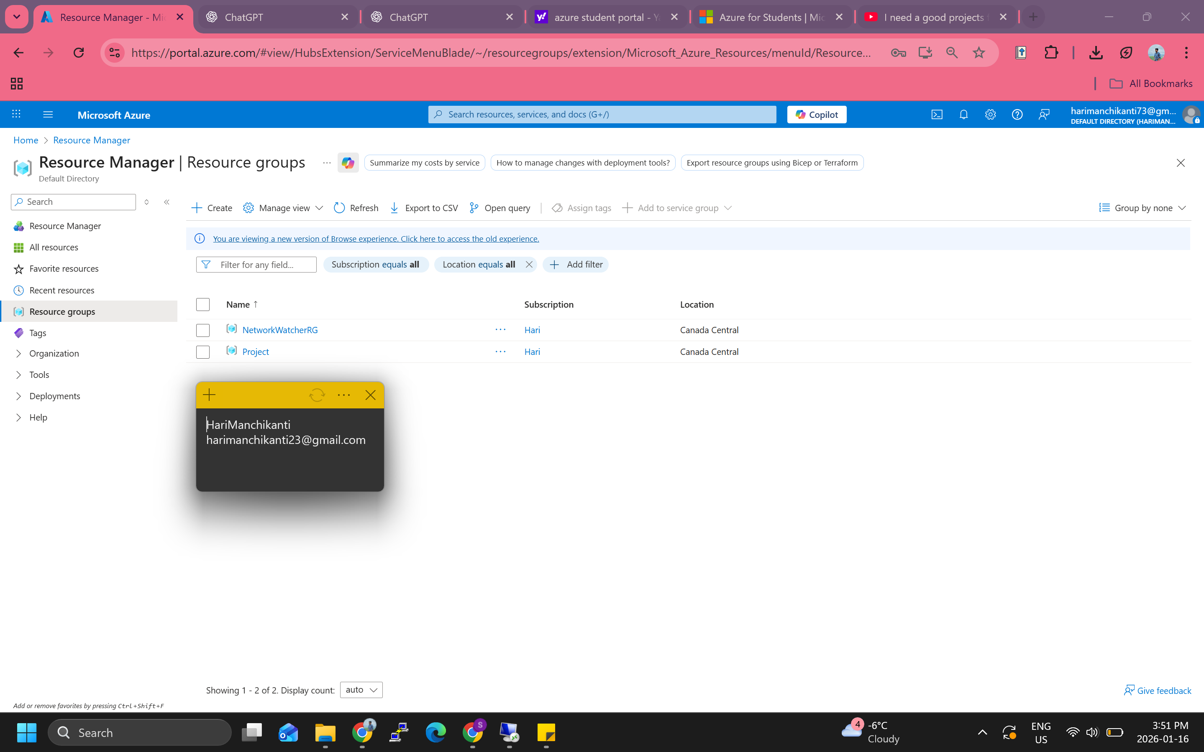
V-net Created
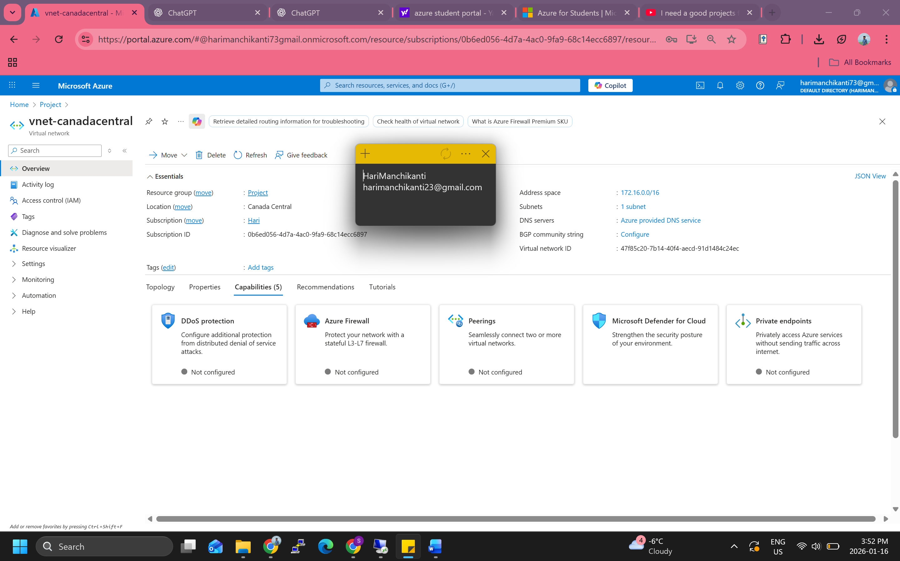
Virtual Machine Created – Domain Controller
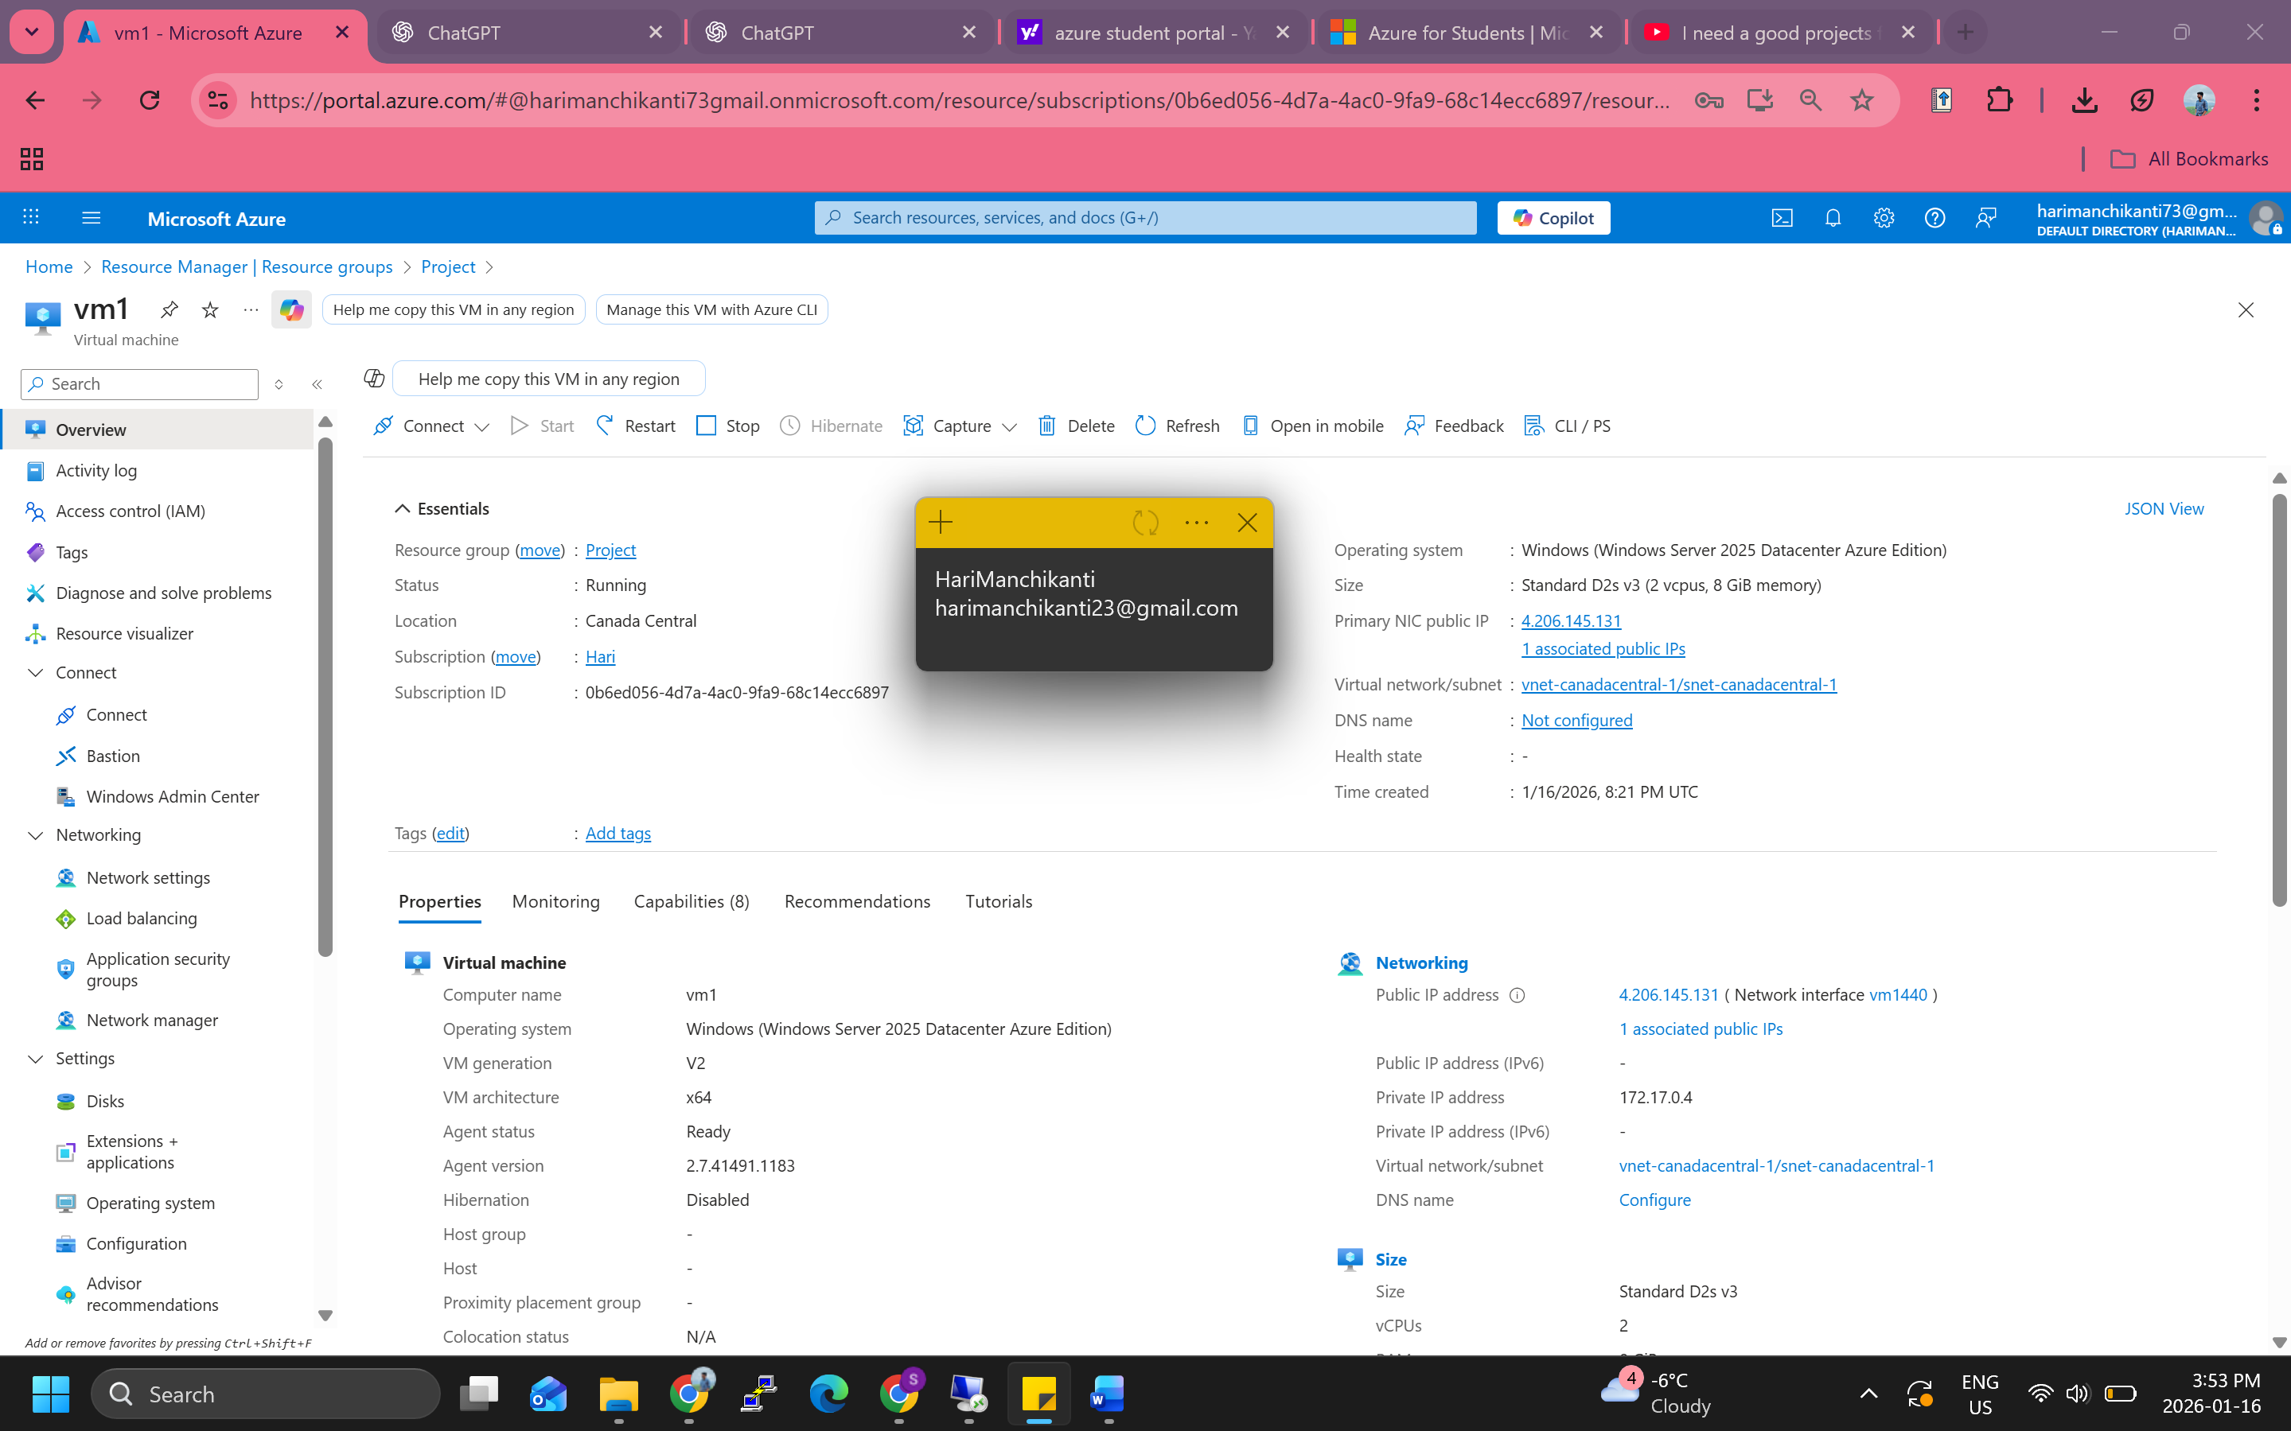
Did RDP to the Machine
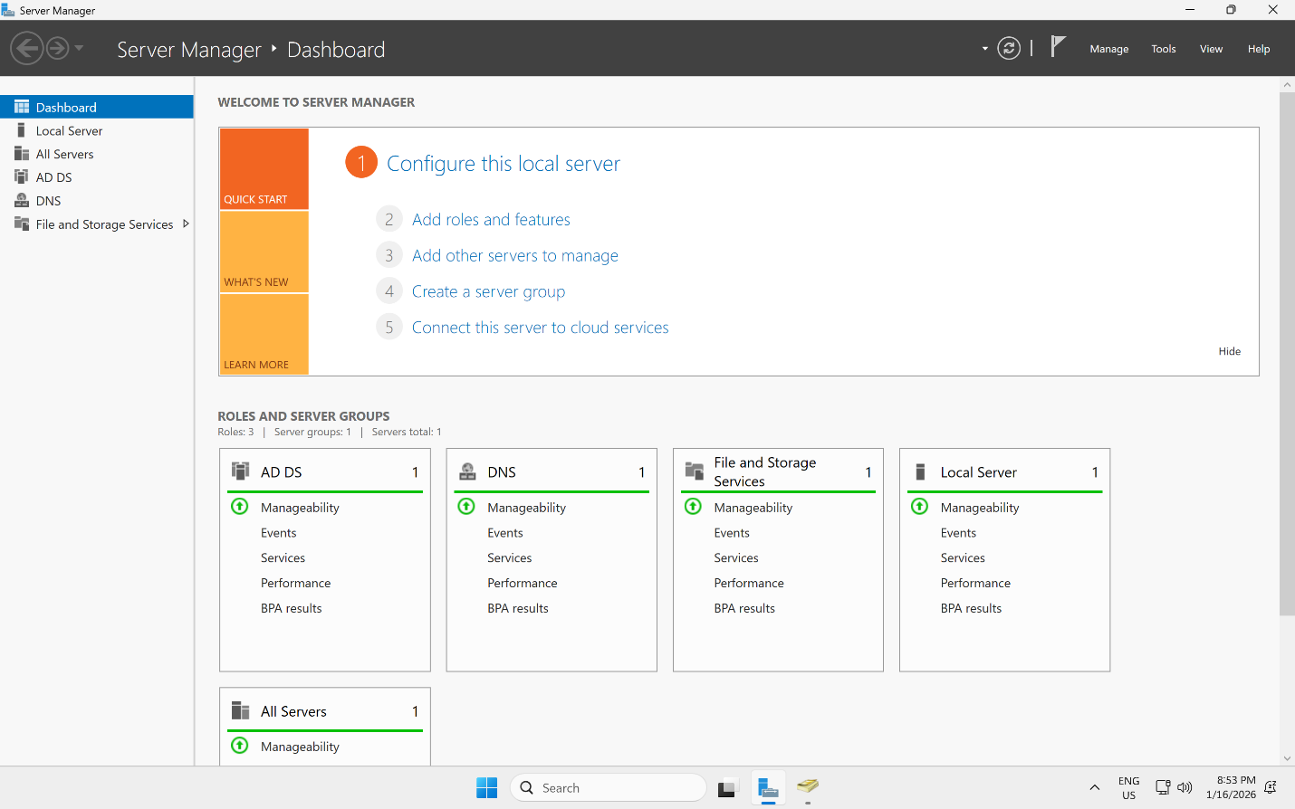
Also, here I have added the AD-DS so that I can manage the users and groups through RDP because in my opinion it will be secure and have passwords to it. We can also do it in local machine, but we need to install RSAT tools to manage it or else we wont be having access to the directory.
I have Added few users and promoted it.
